Agenda: 06/02/20 - 13/02/20

Attendance: Dan, Mehmet, Connor, Niro, Dex

Last week’s [Meeting Minutes](https://docs.google.com/document/d/1r1BuC9lhfuoiNez03X24TwX5VZX-4uInHMDsqw7Mu4g/edit)

What to discuss

* The prototype
* What we are doing next week

What you did last week

* Continued work on pet projects:
  + Dexter
    - Updated Architecture Diagram
    - Added third prediction method - Polynomial regression
    - 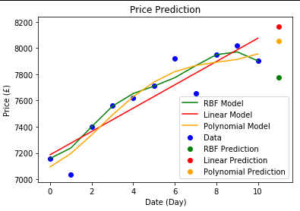
    - Created script to calculate the most accurate balance of prediction methods
      * New predictions have an average of %3.179 difference from the actual value
      * 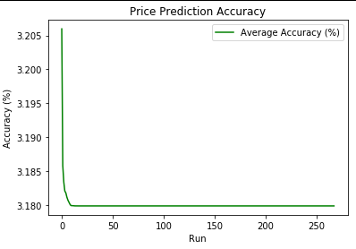
      * Balance of prediction types:
        + Linear: %36.19102212115648
        + RBF: %55.33411275695783
        + Polynomial: %8.47486512188569
    - Updated UI to display predicted values
      * Still requires changes
  + Dan
* Pet project - Social Media Integration
* Put together a research document for Reddit posts and Bitcoin price.
  + Niro
    - Added field for input of user (comparison)
    - Working on retrieving results from the graph to showcase the money being across a period of time
    - Alerting the user for comparison so that they know what user they are comparing with
    - Displaying the comparison on the graph
    - Comparing two users results

Connor

* + Developed python function for API data retrieval.
  + Development successfully json converter in Python for data.
  + Developed web crawler for new pet project, currently acquires link from google to webpages based on user input for search.
  + Mehmet
  + Connect api to front end
  + Represent position details in a table format
  + Started working on global chat system

What to do next week:

* Dexter
  + Use the results from prediction to calculate an ‘up/down’ prediction with a confidence score.
  + Continue to update website to display predictions
  + Add machine learning results to database
* Dan
  + Carry out first hand Twitter & Reddit research.
  + Continue development of Reddit app - host on Azure
* Mehmet
  + Complete connection between backend to front end
  + Determine new pet projects
* Connor
  + Complete data storage (503 service unavailable main hindrance that should be fixed) as testing currently proving errors are present and system not working. Start development with solely function app and not logic app integration to test for 503 error.Test and complete storage to graph functionality.
  + Complete js live data implementation functionality for prototype.
  + Finalise some design features for graphs.
* Niro
* Implement UI requests from other members into conceptual UI Design
* Ensure experience for the user knows exactly what to do efficiently and effectively
* Match user interface with user stories
* Try to ensure the graph shows cases data from different user - first stage of working on comparisons (made up data for now)

Notes:

* Dan - Summarise paper
* Rogerio says dans computer is horrible
* Dexter - Update Architecture diagram with prediction components
* Connor - Try different approaches for data storage
* Dexter - Get another prediction method, calculate the confidence scores for each method and use this, in combination with dans polarity score to create a more accurate prediction
* Move all code to the same repository
* Someone is going to fail this project rogerio says
* Talk about same stuff each week
* Should be on second/third project
* He has never had a group that hasn't had a proper prototype at christmas

Mehemt states the goals

Mehmet - Dynamic buttons will be implemented which will display a table of open positions

Partially achieved - buttons done and open positions will be saved to azure tables, currently doesn't send data to tables on prototype 400 error similar to Dan's error

Dexter:

* Finish gauge chart
* Update line graph to show the optimised prediction - one with fewer errors

Started on prediction stuff, wants to add another deep learning implementation to add to the prediction methods.Can already compare prediction for the day and actual data. Needs to give some clues and statements (accuracy) to make the prediction more easily understandable. No option for choosing prediction length of data, run time too long on too many data sets

Niro - Real sample bitcoin data in comparison chart.

Niro - Implement flexible graphs (different filters/situations)

Connor - Actual bitcoin data (substantial amount) in table whether through automation or manual.

Achieved - all data needs to be implemented with something like for loop or timer (for loop)

Need to get more historical data and implement live data using an Azure function app with a timer trigger and display on graph by next week.

Dan - Store and get social media data from table storage using API and display on website.

Partially achieved - gets data successfully and sends the data but it currently isn't displaying on the prototype 400 error

Polarity shows positive and negative opinion on market change and possible market change, discussed need of some methods/medium to store data

Save positions prices

Project needs more cohesion and interconnectivity

Prototype needs to be ready a week before poster fair

Poster needs more information, more detail that makes more sense, but does not need lots of text.

Needs mention of goals, needs reference to members of group

Conclusions: